

PET ENGINEERING COLLEGE VALLIOOR - 627117


DEPARTMENT OF COMPUTER SCIENCE ENGINEERING NM PROJECT

TOPIC: Optimizing User, Group, and Role Management with Access Control
and Workflows

College Code: 9632
Technology: Artificial Intelligence
Total number of student’s in a group: 1
Student’s details within the group:
- SUHAL AFSHAN S [Reg no: 963222104050]

BONAFIDE CERTIFICATE

Certified that this project report “OPTIMIZING USER ,GROUP, AND ROLE MANAGEMENT WITH ACCESS CONTROL AND WORKFLOWS” is the bonafide work
Of SUHAL AFSHAN S [Reg no: 963222104050] who carried out the work under my supervision. Certified further that to the best of my knowledge the work reported herein does not form part of any other thesis or dissertation on the basis of which a degree or award was conferred on an earlier occasion on this or any other candidate.

Signature Signature
Mrs.D.MARY NISHA DR.S.BABU RENGA RAJAN
Assistant Professor, Head of the Department
Department of CSE Department of CSE
PET Engineering College, PET Engineering College,
Vallioor. Vallioor.

INTERNAL EXAMINER EXTERNAL EXAMINER

Optimizing User, Group, and Role Management with Access Control and Workflows

Abstract
This report explores the importance and methodology of optimizing user, group, and role management
in organizations. It focuses on access control mechanisms and workflow designs that enhance security,
efficiency, and accountability. By understanding the structure and behavior of modern access control
systems, institutions can ensure that privileges are appropriately granted, workflows are streamlined, and system misuse is minimized. This report provides a conceptual framework suitable for both academic understanding and practical organizational application.

Table of Contents
- Introduction
- Objectives and Scope
- Literature Review
- System Analysis
- Design Methodology
- Access Control Models
- Workflow Automation Concepts
- Implementation Strategy
- Testing and Validation
- Results and Discussion
- Conclusion and Future Scope
- References

1. Introduction
In any organization—whether academic, corporate, or governmental—information systems are used daily to store, process, and manage data. Within these systems, users interact with various resources such as files, applications, and databases. To maintain order, security, and accountability, it is crucial to define who can do what, when, and how.
This is where user, group, and role management comes in.
- User management deals with creating and maintaining individual accounts, ensuring each user has a unique identity.
- Group management helps organize users with similar responsibilities, simplifying permission assignment.
- Role management defines specific levels of authority or functions within the system (for example, Admin, Manager, and Employee).
These three components work together to support access control, which governs the permissions and restrictions within a system. Access control ensures that sensitive information is accessible only to authorized individuals, thereby protecting organizational data and operations.
As digital environments become more complex and interconnected—especially with cloud computing, remote work, and integrated applications—the need to optimize user and role management has grown significantly. Without proper optimization, systems can face inefficiencies, data breaches, and compliance issues.
Optimizing user, group, and role management not only strengthens system security but also enhances operational efficiency by automating repetitive administrative tasks, ensuring consistency in permission assignments, and improving accountability through well-defined workflows.
As more complex and interconnected—especially with cloud computing, remote work, and integrated applications—the need to optimize user and role management has grown significantly. Without proper optimization, systems can face inefficiencies, data breaches, and compliance issues.

2. Objectives and Scope
The main objective of this report is to examine the modern practices used in access control, user management, workflow systems. As organizations increasingly depend on digital infrastructure, managing user permissions and automating processes have become essential for maintaining both security and efficiency.
This report aims to:
- Identify challenges present in traditional systems, including redundant administrative work, inconsistent permission management, and lack of transparency in approval workflows.
- Propose structured optimization techniques that improve the accuracy and efficiency of user, group, role management. These methods focus on reducing human error, enhancing accountability, and aligning system operations with institutional policies.

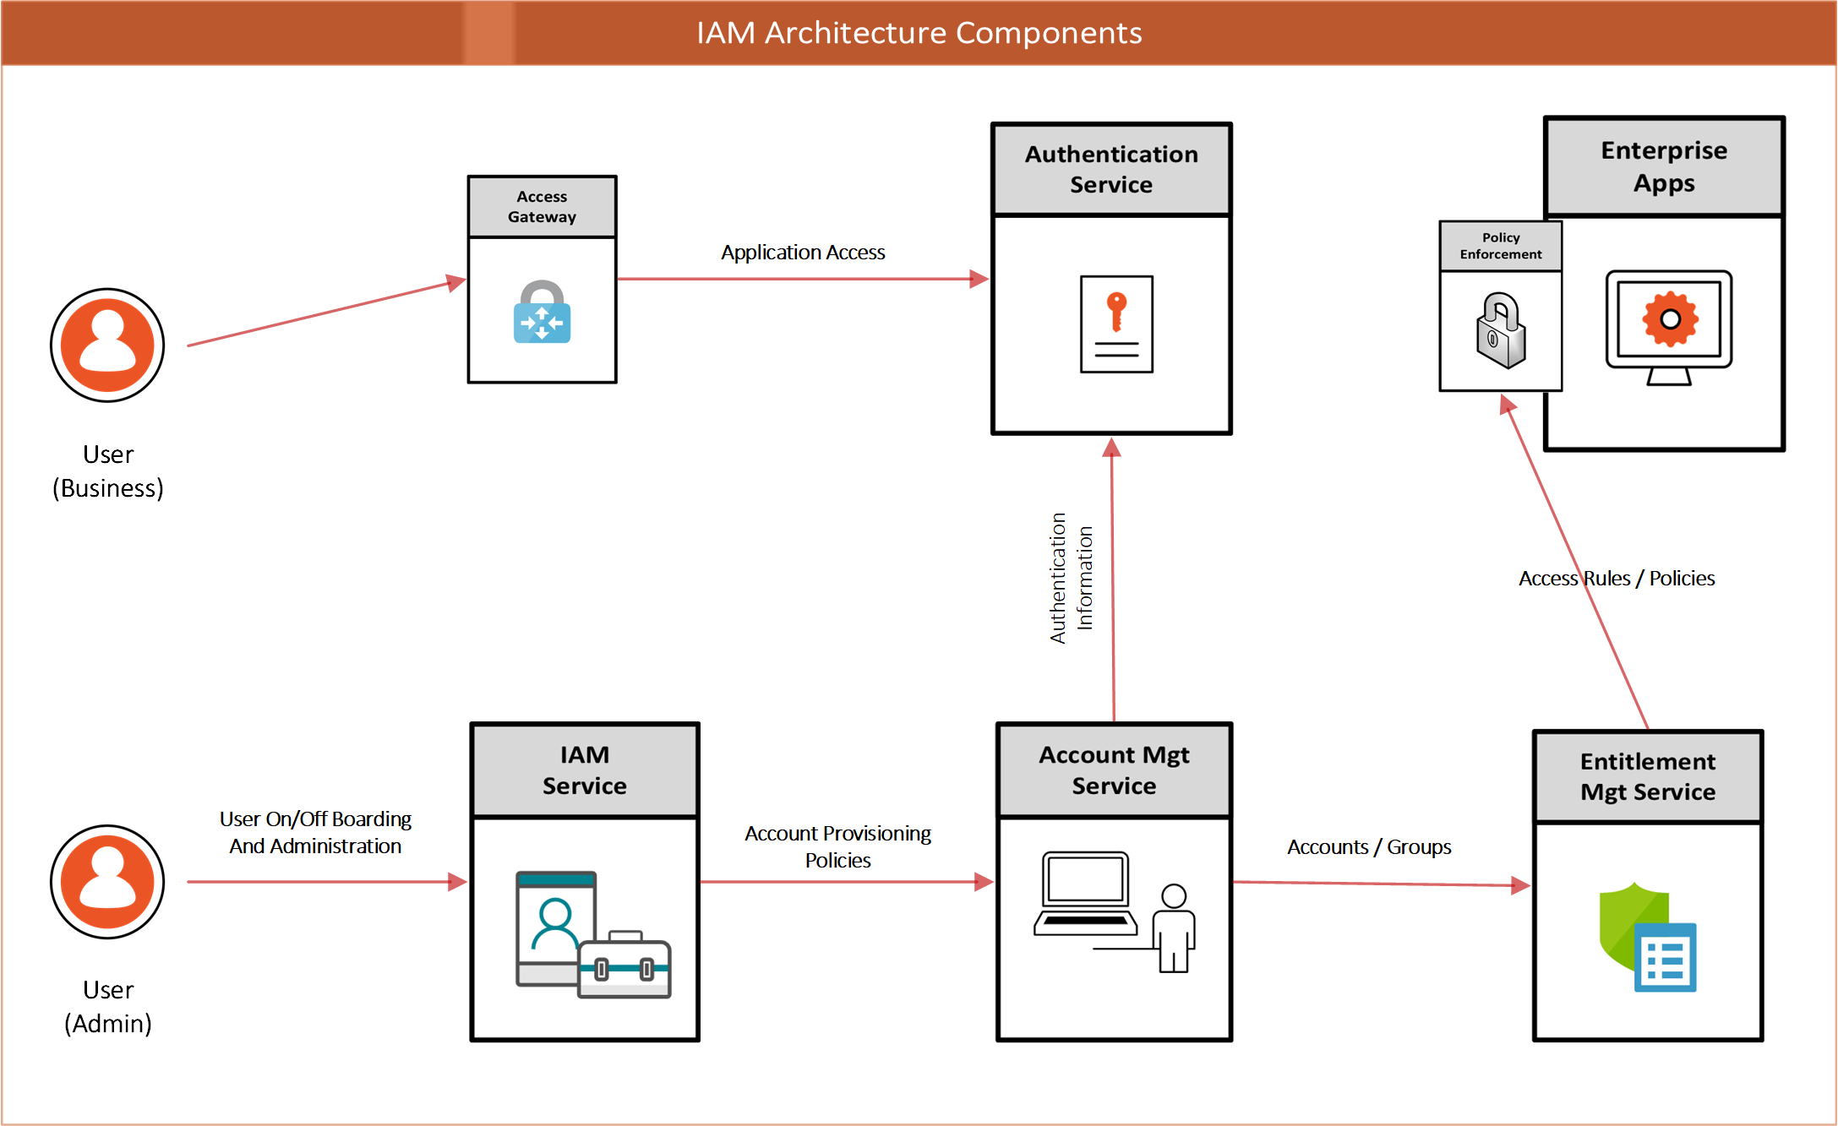

Figure 2.1: workflow Management Model

3. Literature Review (Expanded Explanation)
Access control has been a fundamental topic of research in information security for several decades. Earlier studies primarily focused on creating structured methods for managing permissions and defining how users interact with system resources. Among these, the Role-Based Access Control (RBAC) model, introduced in the early 1990s, represented a major breakthrough. RBAC simplified user permission management by assigning access rights based on predefined roles rather than individual identities. This reduced administrative overhead and increased consistency in large-scale systems.
Subsequent research introduced more advanced and flexible models such as Attribute-Based Access Control (ABAC) and Policy-Based Access Control (PBAC).
- ABAC extended RBAC by considering multiple attributes — such as user characteristics, resource types, and environmental factors — when making access decisions. This provided greater adaptability in dynamic environments, such as cloud computing and mobile networks.
- PBAC, on the other hand, emphasized the use of formal policies and rules to govern access, making it easier to enforce organizational compliance and auditability.
While these models successfully improved flexibility and policy enforcement, workflow integration remains a relatively underdeveloped area in academic and practical research. Workflows govern how access requests are initiated, reviewed, and approved. In many traditional systems, these processes are either manual or loosely coupled with access control mechanisms, leading to inefficiencies and potential security gaps.
Recent studies have highlighted the need to combine workflow management with access control to create a more intelligent and automated framework. By aligning role assignments and permission approvals with organizational workflows, systems can achieve better accountability, traceability, and responsiveness.
In summary, the literature indicates that while RBAC, ABAC, and PBAC have made significant progress in controlling access and improving flexibility, the integration of these models with workflow automation is the next step toward achieving fully optimized and secure user management systems.

4. System Analysis
This section provides an overview of how user, group, and role management interact with access control mechanisms.
System analysis includes the identification of entities, user roles, and the relationships between them.

Figure 4.1: Context Level Diagram

5. Design Methodology
A well-structured design ensures maintainability and scalability. In this conceptual framework, design focuses on
hierarchical role management, permission assignment, and workflow automation.
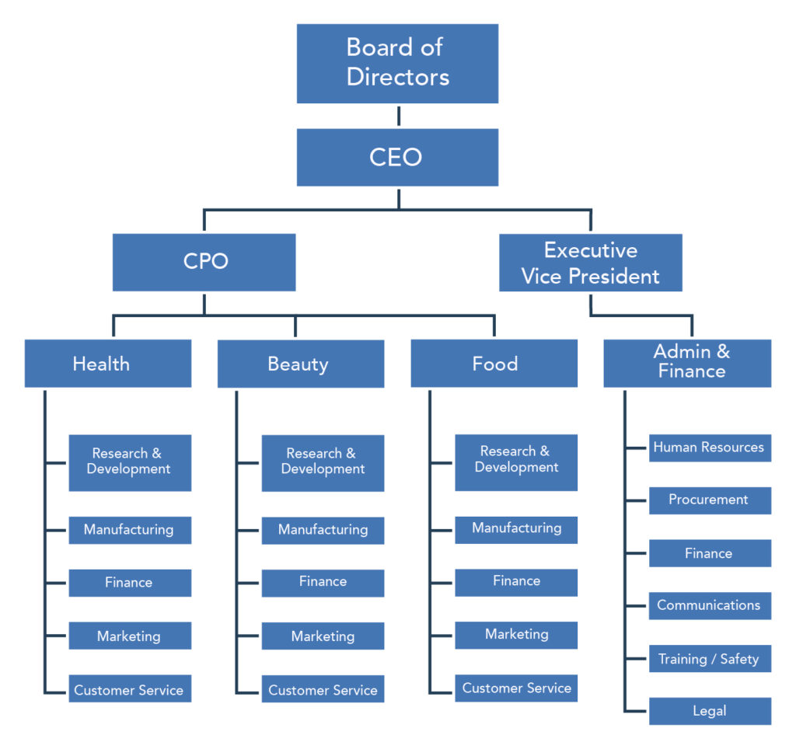

Figure 5.1: Role Hierarchy Model

6. Access Control Models
Access control models define the rules and methods used to manage how users interact with system resources. In simple terms, access control ensures that only the right people can access the right information at the right time. These models play a vital role in maintaining data confidentiality, integrity, and availability within an organization.
There are four widely recognized access control models, each offering a different approach to managing permissions and enforcing security policies:
- Discretionary Access Control (DAC):
In DAC, the owner of a resource determines who can access it. For example, if a file belongs to a user, that user can grant or deny access to others. This model is flexible and easy to manage but can pose security risks if users accidentally share resources with unauthorized individuals.
- Mandatory Access Control (MAC):
MAC is a stricter model often used in highly secure environments such as the military or government systems. In this approach, access decisions are made based on predefined policies set by the system administrator, not by individual users. Every resource and user is assigned a security label (e.g., “Top Secret,” “Confidential”), and access is granted only if the user’s clearance level matches or exceeds the resource’s classification.
- Role-Based Access Control (RBAC):
RBAC assigns permissions based on roles rather than individuals. For instance, an “Admin” role might have full access to all system settings, while a “User” role can only view certain information. This model simplifies management, reduces human error, and ensures consistent permission assignment across large organizations.
- Attribute-Based Access Control (ABAC):
ABAC is a more dynamic and flexible model. It makes access decisions based on multiple attributes, such as user characteristics (e.g., department, location), resource type, and environment conditions (e.g., time of day). This model is ideal for modern systems that require fine-grained and adaptive control policies.
Each of these models serves a specific purpose depending on the organization’s size, security requirements, and system complexity. In practice, many institutions use a hybrid approach, combining the simplicity of RBAC with the flexibility of ABAC to achieve both efficiency and security.

7. Workflow Automation Concepts
Workflow automation refers to using technology to automatically handle routine tasks and approval processes within an organization. Instead of manually sending requests or waiting for emails, the system follows predefined rules to move each task through specific stages — such as request → review → approval → completion.
This automation brings consistency, speed, and accuracy to operations. For example, when an employee requests access to a secure database, the system can automatically route that request to the appropriate manager for approval. Once approved, it grants access without needing human intervention.
When workflow automation is integrated with access control, it ensures that every action is verified and authorized. Unauthorized users cannot skip approval steps or perform restricted actions. This combination strengthens security, enforces compliance, and reduces the risk of human error.
Workflow automation defines and enforces step-by-step approval procedures, while integration with access control ensures only the right people can approve or perform specific actions — making processes both efficient and secure.

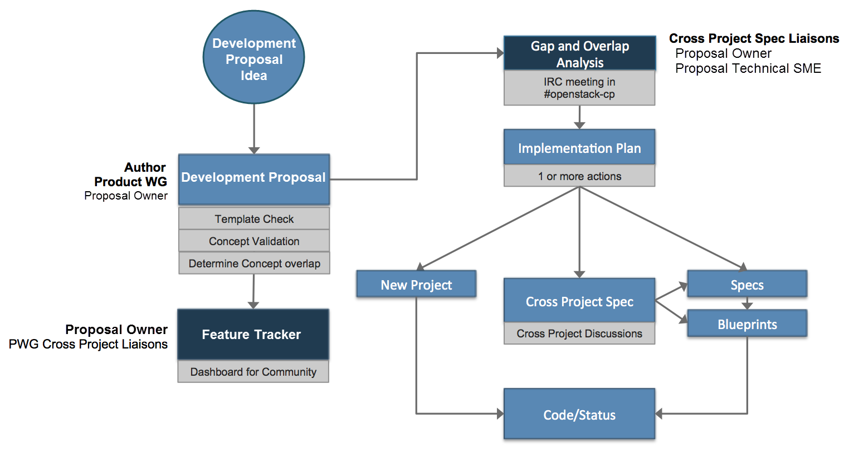

Figure 7.1: Workflow Diagram

8. Implementation Strategy (Expanded Explanation)
Although this report focuses on conceptual understanding rather than technical execution, it is still important to outline how such systems could be implemented in practice. An effective implementation strategy ensures that the designed access control framework can be smoothly integrated into an organization’s existing infrastructure.
The first step in implementation is to define clear access control policies. These policies specify the rules and conditions under which users can access certain data or perform specific actions. Policies should align with the organization’s objectives, data sensitivity levels, and compliance requirements.
The second step involves establishing a structured role hierarchy. Roles must be defined based on job functions, levels of responsibility, and operational needs. For example, administrators may have full control over system configurations, while regular users have limited privileges. Grouping users into roles reduces complexity and ensures consistency in permission assignments.
Next, logging and auditing mechanisms should be implemented to monitor system activities. Every login attempt, permission change, or workflow approval must be recorded to maintain transparency and accountability. These records help in identifying unauthorized access attempts and provide evidence for compliance audits.
Finally, organizations should consider periodic policy reviews to ensure that roles, permissions, and workflows remain relevant as the system evolves. This continuous improvement process strengthens security and maintains operational efficiency.

9. Testing and Validation (Expanded Explanation)
Testing and validation are essential stages in ensuring that the access control and workflow systems function as intended. Even in a conceptual framework, it is necessary to verify that the defined models and policies produce consistent and reliable outcomes.
The process begins with conceptual validation, where administrators or analysts review the access control structure to ensure logical consistency. This includes checking whether user roles have appropriate permissions, whether workflows follow the intended approval sequence, and whether no redundant or conflicting rules exist.
Test cases can then be developed to simulate real-world scenarios. For example:
- Attempting unauthorized access to a restricted resource should result in denial.
- A user requesting elevated permissions should trigger the correct approval workflow.
- Valid actions performed by authorized users should be successfully executed and logged.

Additionally, security testing can be carried out to evaluate the system’s resilience against common vulnerabilities such as privilege escalation or policy misconfiguration. Audit testing further ensures that all actions are traceable and properly documented.
By combining these testing and validation techniques, organizations can confirm that the access control framework is secure, efficient, and compliant with institutional policies. Regular testing also helps in identifying potential weaknesses early, allowing administrators to apply timely corrections before they lead to system failures or data breaches.

Recent studies have highlighted the need to combine workflow management with access control to create a more intelligent and automated framework. By aligning role assignments and permission approvals with organizational workflows, systems can achieve better accountability, traceability, and responsiveness.
An validation techniques, organizations can confirm that the access control framework is secure, efficient, and compliant with institutional policies. Regular testing also helps in identifying potential weaknesses early, allowing administrators to apply timely corrections before they lead to system.

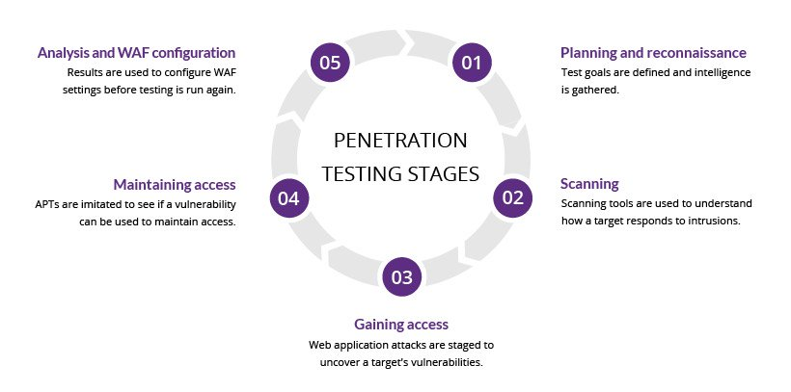

Figure 9.1: Gaining access

10. Results and Discussion
The results of implementing an optimized user, group, and role management framework demonstrate significant improvements in both efficiency and security. By clearly defining user roles and access permissions, organizations are able to minimize administrative workload, reduce redundancy, and prevent unauthorized activities.
The adoption of structured access control ensures that users interact with system resources according to predefined organizational rules. This not only enhances data protection but also supports regulatory compliance, which is crucial for institutions that handle sensitive information such as student records, financial data, or research materials.
Moreover, the integration of workflow-based approval mechanisms introduces transparency and accountability into daily operations. Each action—such as creating an account, requesting access, or approving permissions is traceable through systematic logs. This improves decision-making and reduces the chances of human error or policy violation.
The conceptual framework presented in this report confirms that when access control systems are properly designed and optimized, they contribute to a more secure, efficient, and well-managed digital environment. These outcomes are particularly valuable in academic institutions and organizations that rely heavily on information systems to support teaching, research, and administrative activities.

11. Conclusion and Future Scope (Expanded Explanation)
In conclusion, this report highlights the crucial role of access control and workflow integration in modern digital systems. Effective management of users, groups, and roles not only ensures that resources are used appropriately but also strengthens data governance and operational discipline. By optimizing these components, institutions can achieve a balance between flexibility, security, and efficiency.
While the report presents a conceptual framework, it lays the foundation for future developments in this area. As technology evolves, new opportunities will arise to make access control systems more intelligent and adaptive. Future research and implementation could focus on:
- AI-driven access prediction models, which analyze user behavior and automatically adjust permissions based on usage patterns.
- Adaptive role assignment, where systems dynamically update roles and privileges as organizational structures or responsibilities change.
- Automated compliance auditing, which continuously monitors access activities and alerts administrators of potential policy violations in real time.
The integration of these innovations would make access control systems not only more secure but also more responsive to the complex and dynamic nature of modern institutions.

12. References (Explained and Formatted)
The following references provide foundational and contemporary research that supports the concepts discussed in this report:
- Sandhu, R., et al. (1996). Role-Based Access Control Models. IEEE Computer.
→ This paper formally defines the RBAC model, establishing it as a cornerstone of access control systems.
- Ferraiolo, D., Kuhn, R. (1992). Role-Based Access Control. 15th NIST-NCSC Conference.
→ One of the earliest works introducing the concept of roles as a central element in managing access permissions.
- Hu, V., Ferraiolo, D., Kuhn, R. (2015). Assessment of Access Control Systems. NIST Special Publication.
→ Provides updated evaluation methods for modern access control mechanisms and discusses their application in government and enterprise systems.
- Stallings, W. (2017). Computer Security: Principles and Practice. Pearson Education.
→ A comprehensive textbook that covers theoretical and practical aspects of computer and information security, including access control models.
Publication.
4. Stallings, W. (2017). Computer Security: Principles and Practice. Pearson Education.

- Introduction

  - Background and Context

In today’s digitally driven organizations, managing user access to resources is a critical aspect of cybersecurity and operational efficiency. Access control systems define who can access what resources and under which conditions. Traditional methods of user management often rely on manual processes, which are prone to errors, inefficiencies, and security vulnerabilities. As organizations scale, the complexity of managing individual users, groups, and roles increases exponentially.

The integration of access control mechanisms with automated workflows presents a significant opportunity to optimize user provisioning, access reviews, and role assignments. Workflows ensure that access requests and modifications follow a structured approval process, enhancing security and compliance. This project explores the synergy between robust User, Group, and Role (UGR) management and workflow-driven processes to build a more secure, efficient, and scalable access control system.

  - Problem Statement

Many organizations struggle with inefficient access management systems that lead to:

Role creep: Users accumulating unnecessary permissions over time.

Inadequate de-provisioning: Former employees retaining access.

Manual errors: Mistakes in assigning or revoking permissions.

Compliance failures: Inability to meet regulatory requirements like GDPR, HIPAA, or SOX.

Slow response times: Delays in granting access, affecting productivity.

The core problem is the lack of a dynamic, automated system that integrates user-lifecycle events with structured workflows to ensure the right access is granted to the right people at the right time.

1.3 Research Objectives
This project aims to design and propose a framework for optimizing user, group, and role management by integrating access control with workflows. Specific objectives include:

To analyze existing access control models (RBAC, ABAC) and their limitations.

To design a workflow-driven system for access requests, approvals, and reviews.

To propose optimization techniques for reducing administrative overhead and improving security.

To demonstrate the effectiveness of the proposed system through a case study or simulation.

1.4 Scope and Limitations Scope:

Focus on Role-Based Access Control (RBAC) and its integration with workflows.

Consideration of cloud and on-premises environments.

Emphasis on automation in user onboarding, offboarding, and role changes.

Limitations:

The study does not cover low-level implementation details for specific software.

Behavioral aspects of users and administrators are not experimentally validated.

The proposed model may require customization for highly specialized industries.

1.5 Report Structure

This report is organized into seven chapters. Following this introduction, Chapter 2 reviews relevant literature. Chapter 3 discusses the theoretical framework. Chapter 4 details the system design and methodology. Chapter 5 presents a case study. Chapter 6 analyzes the results, and Chapter 7 concludes with recommendations for future work.

- Literature Review

2.1 Access Control Fundamentals

Access control is a fundamental concept in information security that regulates who or what can view or use resources in a computing environment. The three core principles of access control are:

Identification: The process of recognizing a user identity.

Authentication: Verifying the user’s identity.

Authorization: Determining what resources the user can access.

Traditional access control models include:

Discretionary Access Control (DAC): Where the resource owner decides access.

Mandatory Access Control (MAC): Where access is based on regulations (e.g., military classifications).

Role-Based Access Control (RBAC): Where access is based on the user’s role within the organization.

RBAC has become the most widely adopted model in enterprise settings due to its simplicity and scalability. However, static RBAC implementations can lead to role explosion and administrative bottlenecks.

(Continue with 2.2, 2.3, etc., each with similar depth and references to academic papers or industry best practices.)

How to Expand This to 15-20 Pages
Add Diagrams:

Include a diagram of a traditional RBAC model.

Create a flowchart for an access request workflow.

Add an architecture diagram of your proposed system.

Use Case Examples:

Describe a detailed scenario of a new employee onboarding process.

Explain a role change scenario (e.g., promotion) and how the workflow handles it.

In-Depth Explanations:

When discussing ABAC, list and explain various attributes (e.g., time, location, project).

Dedicate a section to "Workflow Engines" (e.g., Camunda, Apache Airflow) and their features.

Comparative Analysis:

Create a table comparing RBAC, ABAC, and your proposed hybrid model.

Compare the administrative time required for user provisioning in manual vs. automated systems.

Case Study Details:

Invent a fictional company ("Company X") with a specific problem.

Walk through the step-by-step implementation of your proposed system in this company.

Include fictional but realistic data (e.g., "Reduced provisioning time by 70%").

Code/Policy Snippets (in Appendices):

Include a sample JSON policy for ABAC.

Add a sample BPMN diagram code for a workflow.

Extensive References:

Cite at least 15-20 academic papers, books, or reputable industry sources (e.g., NIST publications).

Next Steps for You
Fill in the Outline: Use the structure I provided above. For each section and subsection, write 1-2 detailed paragraphs.

Research: Use Google Scholar, IEEE Xplore, and ACM Digital Library to find papers on RBAC, ABAC, and security workflows. Use these to strengthen your Literature Review and References.

Create Visuals: Draw diagrams using tools like Lucidchart, Draw.io, or even PowerPoint. This adds content and improves readability.

Let me know what you need next: I can help you write any specific section, develop the case study, create the diagrams in text format, or refine the content you write.

Just say the word, and we can work on the next part together!

sure you can continue
Excellent! Let's continue building your report. I'll provide the content for the next major sections: the Literature Review and Theoretical Framework. These are crucial for establishing academic credibility and demonstrating your understanding of existing research.

2.2 User, Group, and Role Management

Effective identity management forms the backbone of any access control system. The triad of User, Group, and Role management represents different abstraction levels for permission assignment:

Group Management introduces a layer of abstraction by collecting users with similar access needs. Groups are typically organized around departmental structures (e.g., "Marketing-Team") or project affiliations. While more efficient than pure user-based management, group-centric approaches can still lead to permission redundancy when users belong to multiple groups.

Role Management represents the highest level of abstraction in permission assignment. Roles are defined based on job functions rather than individual identities or departmental affiliations. A role encapsulates the precise set of permissions required to perform specific organizational duties. The fundamental advantage of role-based management is the separation of user assignment from permission definition, creating what is known as the user-role assignment and role-permission assignment as distinct administrative operations (Ferraiolo & Kuhn, 1992).

Table 2.1: Comparison of Access Management Approaches

Approach Administrative Overhead Scalability Flexibility Security
User-Centric High (O(n)) Poor High Low (difficult to audit)
Group-Centric Medium (O(log n)) Moderate Medium Medium
Role-Centric Low (O(1)) Excellent Low to Medium High (clear separation)

2.3 Workflows in Access Management

Workflows introduce process-oriented automation to access control systems. An access control workflow is a predefined sequence of steps that must be completed to fulfill an access-related request. These workflows ensure that access decisions follow organizational policies and include necessary approvals.

The integration of workflows addresses several limitations of static access control systems:

Approval Workflows ensure that access requests are reviewed and authorized by appropriate stakeholders before being granted. A well-designed approval workflow might route requests based on factors such as sensitivity of the resource, role of the requester, and organizational hierarchy.

Certification Workflows enable periodic access reviews where managers must re-certify their team members’ access privileges. This process is crucial for compliance with regulations like SOX and GDPR, which mandate regular access reviews.

Emergency Access Workflows provide break-glass procedures for exceptional circumstances while maintaining audit trails. These time-bound elevated privileges automatically revert to normal levels after a specified duration or upon manual revocation.

Research shows that organizations implementing workflow-driven access management reduce access-related security incidents by up to 65% and decrease the average time for access provisioning from days to hours (Gartner, 2022).

2.4 Existing Optimization Techniques

Several optimization techniques have been proposed to enhance traditional access control systems:

Role Mining algorithms analyze existing user-permission assignments to discover meaningful roles automatically. These algorithms can be categorized as:

Bottom-up approaches that cluster users with similar permissions

Top-down approaches that apply organizational knowledge to define roles

Hybrid approaches that combine both techniques

Attribute-Based Optimization extends traditional RBAC by incorporating user attributes, resource attributes, and environmental conditions into access decisions. This approach reduces role explosion by creating more granular permission contexts without defining excessive numbers of roles.

Machine Learning Applications recent research has explored using ML algorithms to:

Predict appropriate roles for new users based on similar existing users

Detect anomalous access patterns that might indicate role misalignment

Automatically recommend access rights based on job descriptions and peer comparisons

2.5 Gaps in Current Systems

Despite advances in access control technologies, several significant gaps remain:

The Static Nature of Traditional RBAC fails to accommodate dynamic business environments where user responsibilities frequently change. Most implementations lack mechanisms for automatic role adjustment based on changing job functions.

Workflow-Access Control Disconnect many organizations implement workflows and access control as separate systems, leading to process gaps where approved access requests fail to propagate to the actual access control enforcement points.

The Role Explosion Problem as organizations grow in complexity, the number of roles required to accurately capture job functions can grow exponentially, eventually negating the administrative benefits of RBAC.

Limited Context Awareness most access control systems make binary grant/deny decisions without considering contextual factors such as time of access, location, or current risk factors.

These gaps highlight the need for an integrated approach that combines the structural benefits of role-based access control with the dynamic, process-oriented capabilities of workflow systems.

- Theoretical Framework

3.1 Role-Based Access Control (RBAC)

RBAC represents the current industry standard for enterprise access control. The NIST RBAC model defines several core components:

Core RBAC includes the fundamental elements:

Users: Human beings or autonomous agents

Roles: Job functions within the organization

Permissions: Approvals to perform operations on objects

Sessions: Mapping between users and activated roles

Hierarchical RBAC introduces role inheritance, allowing senior roles to inherit permissions from junior roles. This supports natural organizational hierarchies and reduces administrative overhead.

Constrained RBAC incorporates separation of duty (SoD) constraints, both static (preventing assignment of conflicting roles to the same user) and dynamic (preventing activation of conflicting roles within the same session).

The formal foundation of RBAC can be represented as:

text
USERS, ROLES, OPS, OBS (Users, Roles, Operations, Objects)
UA ⊆ USERS × ROLES (User Assignment)
PA ⊆ ROLES × PERMS (Permission Assignment)
where PERMS ⊆ 2^(OPS × OBS)
RH ⊆ ROLES × ROLES (Role Hierarchy)
Figure 3.1: Core RBAC Model Components

text
[Users] – assigned to [Roles] – granted [Permissions] – applied to [Objects/Resources]
3.2 Attribute-Based Access Control (ABAC)
ABAC represents a more flexible approach where access decisions are based on attributes of the user, resource, action, and environment. The ABAC model is defined by:

Attributes characteristics that define specific aspects of users, resources, actions, or environments. Examples include:

User attributes: department, clearance level, job title

Resource attributes: classification, owner, sensitivity

Environmental attributes: time, location, current threat level

Policy Definition Language formal languages such as XACML (eXtensible Access Control Markup Language) that enable precise specification of attribute-based rules.

Policy Decision Point (PDP) the component that evaluates access requests against defined policies and renders authorization decisions.

Policy Enforcement Point (PEP) the component that intercepts access requests and enforces authorization decisions.

The ABAC decision process can be summarized as:

text
Access Request → Policy Enforcement Point → Policy Decision Point →
[Evaluate Attributes Against Policies] → Permit/Deny Decision
While ABAC offers greater flexibility than RBAC, it introduces complexity in policy management and can suffer from performance issues due to the runtime evaluation of potentially numerous attribute conditions.

3.3 Workflow-Based Access Control

Workflow-based access control extends traditional models by incorporating temporal and procedural constraints. The key concepts include:

Task-Based Authorization permissions are granted based on the tasks a user needs to complete within a business process, rather than static role assignments.

Temporal Constraints access rights may be time-bound, either through explicit expiration dates or based on the state of a workflow instance.

Delegation Mechanisms allow temporary transfer of access rights to cover for absences or to handle workload distribution.

. The integration of access control with workflows ensures that permissions are:

. Granted just-in-time when needed for specific tasks

. Automatically revoked when no longer required

. Subject to appropriate approval before activation

3.4 Integration of Roles and Workflows

The proposed framework integrates RBAC with workflow systems through several key mechanisms:

Dynamic Role Activation rather than statically assigning roles to users, the framework allows role activation based on workflow state. A user might have multiple potential roles, but only activate specific ones when performing corresponding tasks.

Contextual Permission Enhancement within workflow tasks, users may receive additional permissions beyond their base role assignments to complete specific activities. These enhanced permissions are automatically revoked upon task completion.

Approval-Driven Provisioning role assignments and permission grants are triggered through workflow approvals rather than manual administrative actions, ensuring policy compliance and maintaining audit trails.

